

MANIPAL SCHOOL OF INFORMATION SCIENCES
(A Constituent unit of MAHE, Manipal)

Development of Bayesian Physics-Informed
Neural Network Framework for Robust
Analog Circuit Performance

Reg. Number | Name | Branch
251100660001 | Akshitha Shetty | AI/ML
251100660016 | Jai Kishan K C | AI/ML
251100660029 | Kausthubha Bhat | AI/ML

Under the guidance of

Dr. Ribu Mathew
Associate Professor,
Manipal School of Information Sciences,
MAHE, MANIPAL

13/11/2025


TABLE OF CONTENTS
Abstract 01
1.Introduction 02
1.1 Background 02
1.2 Motivation 03
1.3 Problem Statement and Objectives 03
1.4 Project Overview and Flow 04
2.Objectives 05
2.1 Data Analysis and Baseline Establishment 05
2.2 Development of Unified PINN Framework 05
2.3 Inverse Design and Optimization 05
2.4 Uncertainty Quantification (UQ) 06
3. Literature Survey 07
3.1 Overview 07
3.2 Review of Related Works 07
3.3 Research Gaps and Motivation 09
4. Implementation and Architecture 10
4.1 System Overview 10
4.2 Dataset Generation and Preprocessing 10
4.3 RM_OptiPINN Architecture 10
4.4 Physics-Informed Loss Function 12
4.5 Inverse Design Algorithm 12
4.6 Uncertainty Quantification (UQ) 13
4.7 Deployment Interface 14
5. Work Done 15
5.1 Phase 1: Exploratory Data Analysis (EDA) 15
5.2 Phase 2: Baseline Modeling and Initial Comparison 15
5.3 Phase 3: Development of Unified RM_OptiPINN 16
5.4 Phase 4: Hyperparameter Tuning 16
5.5 Phase 5: Final Comparative Analysis 16
5.6 Phase 6: Inverse Design and Uncertainty Quantification 18
6. Results 19
7. Conclusions 23
8. Scope for future work 24
References 25

LIST OF FIGURES AND TABLE
Figure 1.1: | Traditional vs. ML-Based Transistor Sizing Approaches. | 02
Figure 4.1: | Comparison of Typical Neural Network vs. Physics-Informed Neural Network Architecture 1. | 11
Figure 4.2: | Flowchart of the Inverse Prediction Mechanism using Trainable Tensor. | 13
Figure 4.3: | Tkinter-based Application for Inverse Design and Uncertainty Quantification 3. | 14
Figure 5.1: | $R^{2}$ Scores of the RM_OptiPINN Model Across 9 Regression Targets. | 17
Figure 5.2: | Performance Comparison: RM_OptiPINN vs. RF, SVR, and Standard DNN. | 17
Figure 5.3: | Scatter Plots showing Predicted vs. Actual Values for Gain, Bandwidth, and Power. | 17
Figure 6.2: | RMSE scores (lower is better) showing minimal deviation from SPICE simulations. | 20
Figure 6.3: | Performance Benchmarking of RM_OptiPINN vs. RF, SVR, and Standard DNN. | 21
Figure 6.4: | Screenshot of the deployed Application showing Inverse Prediction results. | 22
Table 6.1: | $R^{2}$ Scores Achieved by RM_OptiPINN | 19

Abstract

The design and optimization of analog circuits, such as Operational Amplifiers (OpAmps), are critical for low-power and mixed-signal systems but face significant scalability challenges when relying on traditional simulation tools like Cadence¹. To address these limitations, this project proposes a robust machine learning framework that leverages Physics-Informed Neural Networks (PINNs) to accelerate the prediction of circuit performance metrics while ensuring adherence to physical laws.

The work began with an extensive Exploratory Data Analysis (EDA) on a dataset comprising 16,000 samples across five distinct circuit classes, generated by varying transistor width parameters. Initially, the study focused on predicting individual performance metrics, which established a baseline for accuracy. Subsequently, a unified RM_OptiPINN model was developed to simultaneously predict nine critical circuit metrics—including Gain, Bandwidth, Power, and Phase Margin—achieving high regression accuracy (e.g., $R^{2 }> 0.99$ for key metrics).

Following rigorous hyperparameter tuning to optimize model complexity, the framework was benchmarked against standard base models (Random Forest, DNN, SVR) to demonstrate superior generalization capabilities³. Beyond forward prediction, the project implemented an inverse design optimization capability using a trainable PyTorch tensor, allowing for the retrieval of optimal design parameters from desired performance specifications⁴. Finally, to enhance reliability, Uncertainty Quantification (UQ) was integrated using Monte Carlo (MC) Dropout, providing a probabilistic measure of confidence in the model's predictions⁵. The study concludes by outlining future work on advanced Bayesian Neural Networks and EpiNets to further refine uncertainty estimation.

Introduction

  - Background
Analog and mixed-signal circuits, particularly Operational Amplifiers (OpAmps), serve as the backbone of modern low-power electronics, acting as critical interfaces between the real world and digital processing systems. As the demand for high-performance computing and miniaturized devices grows, the complexity of designing these circuits increases exponentially. Traditionally, the design process relies heavily on Electronic Design Automation (EDA) tools like Cadence Virtuoso. While these tools provide high-fidelity simulations using SPICE models, they are computationally expensive and time-consuming.
Designing a robust analog circuit involves determining the optimal transistor dimensions (widths and lengths) to satisfy multiple conflicting performance metrics such as Gain, Bandwidth, Power, and Phase Margin. A slight deviation in these parameters due to manufacturing variations can lead to significant performance degradation. Consequently, designers often resort to iterative "trial-and-error" simulations, which suffer from scalability issues as the number of design parameters increases.
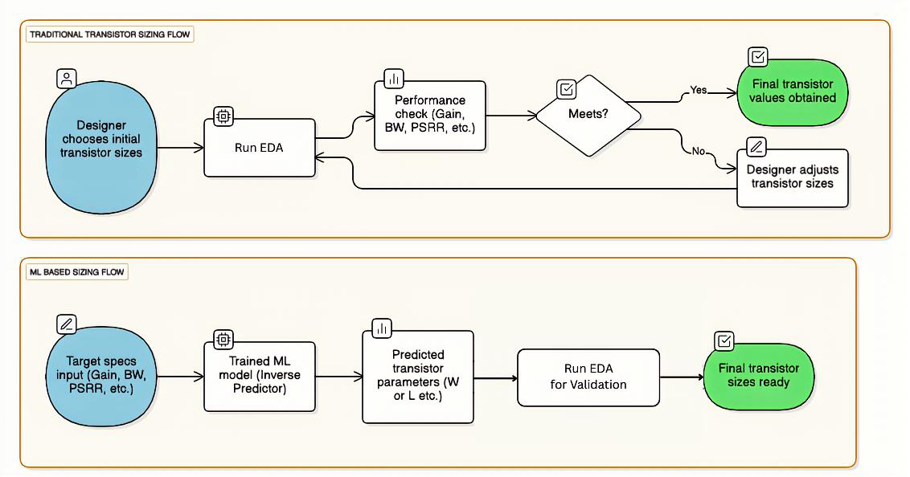
Fig. 1.1: Traditional vs. ML-Based Transistor Sizing Approaches.

1.2 Motivation
The limitations of traditional simulation tools have paved the way for Machine Learning (ML) integrated design workflows. ML models can approximate the complex mapping between circuit parameters and performance metrics, offering a speedup of several orders of magnitude compared to SPICE simulations. However, standard purely data-driven ML models (like standard Neural Networks or Random Forests) often lack generalization capability outside their training data and do not inherently respect the physical laws governing circuit behavior (e.g., Kirchhoff's laws or saturation region constraints).
This project is motivated by the need for a Physics-Informed Neural Network (PINN) approach that combines the speed of data-driven learning with the reliability of physical constraints. Furthermore, since real-world manufacturing introduces noise and variability, a deterministic prediction is insufficient. There is a critical need for a Bayesian framework (or probabilistic approach) that not only predicts performance but also quantifies the uncertainty associated with those predictions, ensuring robust design.
1.3 Problem Statement and Objectives
The primary objective of this work is to develop a robust, uncertainty-aware machine learning framework for predicting and optimizing analog circuit performance. Specifically, this project aims to:
- Analyze and Preprocess: Perform comprehensive Exploratory Data Analysis (EDA) on a 16,000-sample dataset to understand parameter distributions and correlations.
- Develop a PINN Framework: Build a Physics-Informed Neural Network (RM_OptiPINN) capable of accurately predicting 9 key circuit metrics (Gain, Bandwidth, Power, etc.) while adhering to physical constraints.
- Enable Inverse Design: Create a mechanism to predict optimal design parameters (transistor widths) given a set of desired performance specifications.
- Quantify Uncertainty: Implement Monte Carlo (MC) Dropout to estimate model confidence, providing a stepping stone toward full Bayesian Neural Networks (BNN).
1.4 Project Overview and Flow
The methodology adopted in this project follows a systematic progression:
- Data Analysis: The study began with an in-depth EDA of the dataset, which categorizes circuits into 5 classes based on the variation of transistor width parameters (e.g., Class 0 for Width 1/2 variations).
- Baseline Modeling: Initial efforts focused on predicting single metrics (e.g., Gain) to establish baselines. This was followed by a comparison of a preliminary 4-metric model against base models like Random Forest, Deep Neural Networks (DNN), and Support Vector Regressors (SVR).
- Unified Model Development: The core model was expanded to predict all 9 performance metrics simultaneously. Rigorous hyperparameter tuning was conducted to optimize model complexity.
- Inverse Design & UQ: Finally, an inverse prediction module using trainable tensors was developed, and uncertainty quantification was implemented to assess the reliability of the predictions.

2. Objectives
The primary goal of this project is to overcome the scalability and efficiency bottlenecks in traditional analog circuit design by developing a Physics-Informed Neural Network (PINN) framework. This framework aims to provide rapid, accurate, and physically consistent predictions of circuit performance while enabling inverse design capabilities.
The specific objectives of this work are as follows:
2.1. Data Analysis and Baseline Establishment
- To conduct a comprehensive Exploratory Data Analysis (EDA) on a generated dataset of 16,000 samples, identifying the correlations between transistor variations (widths/lengths) and circuit performance.
- To categorize the dataset into distinct classes based on parameter variation (e.g., varying Width 1/2 vs. Width 3/4) to understand the impact of specific design choices.
- To develop baseline machine learning models (Random Forest, SVR, and Standard DNN) for predicting individual performance metrics and establish a benchmark for accuracy.
2.2. Development of Unified PINN Framework
- To design a Multi-Output Physics-Informed Neural Network (RM_OptiPINN) capable of simultaneously predicting all 9 critical performance metrics (Gain, Bandwidth, Power, Phase Margin, etc.) from a single model architecture.
- To enforce physical consistency in predictions, ensuring that the model generalizes better than standard data-driven approaches.
- To perform rigorous hyperparameter tuning to determine the optimal model complexity, balancing computational efficiency with prediction accuracy ($R^{2}$ score).
2.3. Inverse Design and Optimization
- To implement an Inverse Design mechanism using a trainable tensor approach in PyTorch. This allows the system to reverse-engineer the optimal transistor widths required to achieve a specific set of target performance specifications
2.4. Uncertainty Quantification (UQ)
- To integrate Bayesian approximation techniques within the neural network.
- To quantify the epistemic uncertainty in the model’s predictions, providing designers with a confidence interval for each output, which is crucial for manufacturing reliability.

3. Literature Survey

3.1 Overview

The transition from manual, equation-based transistor sizing to automated learning-based frameworks has been a major area of research in Analog IC design. Early approaches relied on optimization algorithms like Genetic Algorithms (GA) or Particle Swarm Optimization (PSO), which, while effective, were computationally intensive. Recent literature has shifted towards Deep Learning (DL) and Physics-Informed Machine Learning (PIML) to address high-dimensionality and data scarcity. This survey reviews key contributions in this domain, focusing on neural architecture advancements and uncertainty quantification.

3.2 Review of Related Works

Deep Learning for Analog IC Automation

Chavan et al. (2024) [2] proposed a novel "TriNet" Architecture for enhanced analog IC design automation. Their work focused on overcoming the limitations of single-stream neural networks by utilizing a three-branch architecture to capture diverse feature representations from circuit data.

Key Contribution: The TriNet model demonstrated significant improvements in predicting circuit specifications by effectively fusing information from different data representations.

Relevance: This work highlights the importance of specialized neural architectures over generic models for complex analog tasks, motivating our choice of a tuned, multi-output architecture.

Singhal et al. (2024) [4] explored Artificial Neural Network (ANN) Driven Optimization for analog circuit performance. Presented at the IEEE Latin American Electron Devices Conference, this study demonstrated how ANNs could replace iterative SPICE simulations for faster convergence.

Key Contribution: They validated that simple ANNs could approximate the non-linear relationship between transistor sizes and performance metrics like Gain and Bandwidth.

Limitation: The approach was largely data-driven and deterministic, lacking the ability to assess the reliability of predictions (uncertainty) or enforce physical laws explicitly.

Physics-Informed and Bayesian Neural Networks

As data-driven models often violate physical constraints, Yang et al. (2020) [3] introduced B-PINNs (Bayesian Physics-Informed Neural Networks).

Key Contribution: This framework combined the governing physical equations (PDEs) with Bayesian inference, allowing the model to solve forward and inverse problems even in the presence of noisy data. It was a foundational step in merging "physics" with "probability."

Relevance: Our project builds on this concept but adapts it specifically for circuit design, where "physics" refers to circuit laws (Kirchhoff’s laws, saturation constraints) rather than fluid dynamics PDEs.

Most recently, Nair et al. (2025) [1] proposed E-PINNs (Epistemic Physics-Informed Neural Networks) to address the high computational cost of standard B-PINNs.

Key Contribution: E-PINNs specifically target epistemic uncertainty (uncertainty due to lack of knowledge/data) and separate it from aleatoric uncertainty (noise). They achieved accuracy comparable to B-PINNs but with significantly lower computational overhead.

Limitation: The authors noted that performance is highly sensitive to hyperparameter tuning, a challenge we address in our project via Optuna optimization.

3.3 Research Gaps and Motivation

While existing literature demonstrates the power of ML in circuit design (TriNet, ANNs) and the robustness of B-PINNs in scientific computing, there is a notable gap in applying Bayesian Physics-Informed frameworks specifically to Analog Circuit Sizing. Most circuit automation tools are either purely data-driven (ignoring physics) or purely deterministic (ignoring uncertainty).

This project addresses these gaps by developing a Bayesian PINN framework that:

Incorporates physical circuit constraints (unlike standard ANNs).

Provides Uncertainty Quantification via MC Dropout (addressing the reliability gap).

Enables Inverse Design for practical parameter sizing.

4. Implementation and Architecture

4.1 System Overview
The proposed framework is designed to bridge the gap between traditional simulation accuracy and machine learning speed. The system operates on a "Simulate-Train-Optimize" workflow, where high-fidelity SPICE data is used to train a Physics-Informed Neural Network (PINN). This PINN then serves as the core engine for two critical tasks: forward prediction of circuit metrics and inverse prediction of transistor sizes.
4.2 Dataset Generation and Preprocessing
To ensure the model learns the complex non-linearities of analog circuits, a comprehensive dataset was generated using Cadence Virtuoso simulations.
- Data Volume: The dataset consists of 16,000 samples.
- Class Stratification: The data is divided into 5 distinct classes (Class 0 to Class 4). Each class corresponds to a specific variation strategy where different subsets of transistor widths were varied (e.g., Class 0 involves varying $W_{\left\{1,2\right\}}$ while holding others constant). This stratification helps the model understand parameter sensitivity.
- Input Features: The model takes 9 inputs: Temperature, Bias Current ($I_{\left\{dc\right\}}$), Compensation Capacitor ($C_{C}$), Length ($L$), and five Transistor Widths ($W_{\left\{1,2\right\}},W_{\left\{3,4\right\}},W_{\left\{5,8\right\}},W_{6},W_{7}$).
- Preprocessing: All input features are standardized using Z-score normalization to ensure zero mean and unit variance, which prevents gradients from vanishing during training.
4.3 RM_OptiPINN Architecture
The heart of the framework is the RM_OptiPINN (Robust Multi-Output Physics-Informed Neural Network). Unlike a standard "black-box" neural network, this architecture is designed to map design parameters directly to performance metrics while maintaining physical consistency.
Network Topology:
- Input Layer: 9 Neurons (corresponding to the design parameters).
- Hidden Layers: Three fully connected layers with 128 neurons each. This depth was chosen to capture high-order interactions between circuit components.
- Activation Function: The Rectified Linear Unit (ReLU) is applied after each hidden layer to introduce non-linearity.
- Dropout Layers: To enable Bayesian approximation, Dropout layers are inserted between hidden layers. These randomly deactivate neurons during training to prevent overfitting and are kept active during inference for uncertainty quantification.
- Output Layer: 9 Neurons predicting Gain, Bandwidth, Power, Phase Margin, etc.
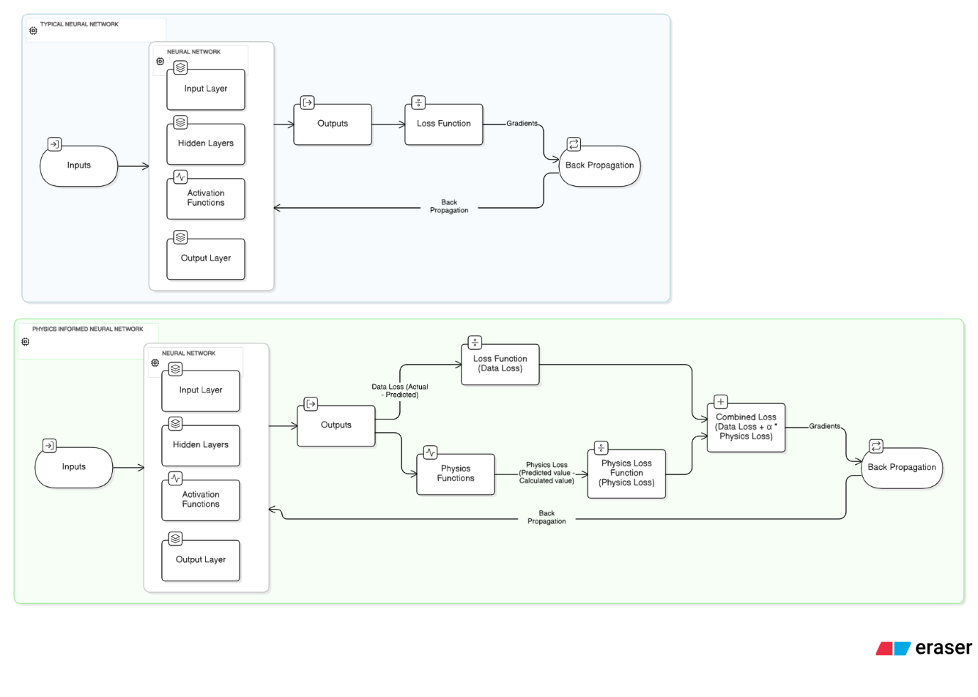
Fig. 4.1: Comparison of Typical Neural Network vs. Physics-Informed Neural Network Architecture 1.
4.3.1 Comparison: Standard Neural Network vs. Physics-Informed Neural Network
To understand the architectural advantage of our approach, it is essential to distinguish between a standard data-driven model and the proposed Physics-Informed Neural Network (PINN).
1. Standard Neural Network (Black-Box Approach)
In a typical Neural Network (as shown in Fig 4.1, top), the learning process is purely data-dependent.
- Workflow: The model takes inputs (transistor widths), passes them through hidden layers with activation functions, and generates outputs.
- Optimization: The loss function strictly calculates the error between the predicted value and the actual value (Data Loss).
- Limitation: The network blindly minimizes this error without "understanding" the underlying system. It might predict a negative Power or a Gain that violates the conservation of energy if such patterns exist as noise in the training data. It relies solely on Back Propagation of the data error.
- Physics-Informed Neural Network (Gray-Box Approach)
The PINN architecture (as shown in Fig 4.1, bottom) introduces a parallel "reasoning" branch.
- Workflow: Like the standard network, it predicts performance metrics. However, these predictions are simultaneously fed into a Physics Function block.
- Optimization: The Back Propagation is driven by a Combined Loss:
- $Loss_{\left\{total\right\}}=Loss_{\left\{Data\right\}}+α⋅Loss_{\left\{Physics\right\}}$
- Physics Loss: This component calculates the deviation from known physical equations (e.g., $Gain\backslash approx g_{m\backslash cdot}R_{\left\{out\right\}}$). If the network predicts a value that mathematically contradicts the input parameters, the Physics Loss spikes, forcing the weights to adjust.
- Advantage: This ensures the model's predictions are not just statistically likely but physically plausible, leading to better generalization on unseen data.
4.4 Physics-Informed Loss Function
To ensure the predictions are not just statistically accurate but also physically valid, the network minimizes a composite loss function:
$$Loss_{\left\{total\right\}}=Loss_{\left\{data\right\}}+λ⋅Loss_{\left\{physics\right\}}$$
- Data Loss ($Loss_{data}$): Measures the Mean Squared Error (MSE) between the model’s predictions and the actual SPICE simulation values.
- Physics Loss ($Loss_{physics}$): A regularization term that penalizes violations of known circuit laws. For example, ensuring that Power is always positive and that the Gain-Bandwidth product remains consistent with the topology's theoretical limits.
4.5 Inverse Design Algorithm
A key requirement for circuit designers is finding the optimal transistor sizes for a desired set of specifications (e.g., "I need a Gain of 60dB"). Since neural networks are non-invertible functions, we implemented an optimization-based inverse method using Trainable PyTorch Tensors.
Process Flow:
- Target Definition: The user inputs the desired performance metrics (e.g., Gain, Phase Margin).
- Initialization: A random set of input parameters (Transistor Widths) is initialized as a trainable tensor.
- Forward Pass: These inputs are passed through the pre-trained, frozen RM_OptiPINN to predict current performance.
- Gradient Descent: The error between the predicted and desired performance is calculated. Gradients are backpropagated to update the inputs (widths) rather than the model weights.
- Convergence: This loop continues until the inputs converge to values that satisfy the target specifications.

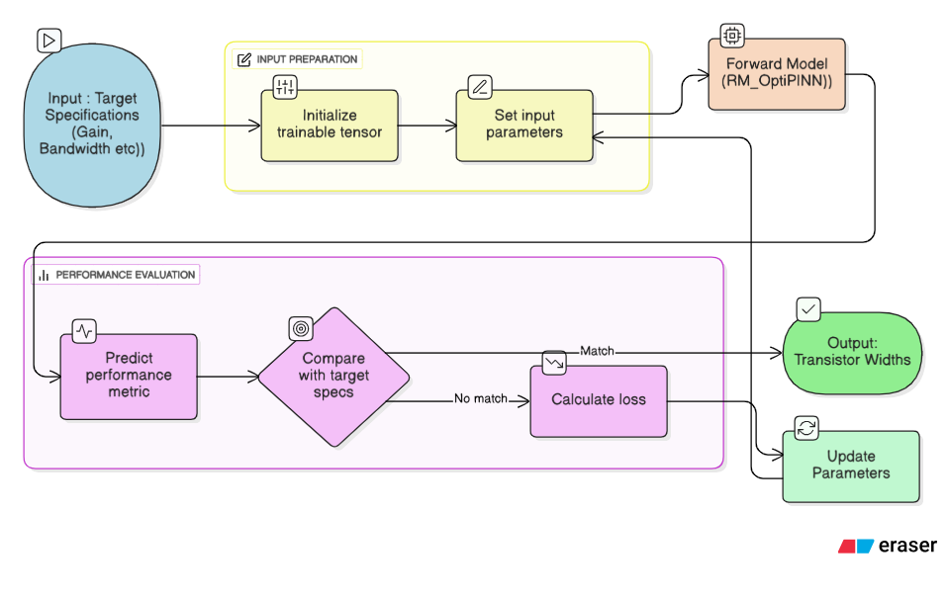
Fig. 4.2: Flowchart of the Inverse Prediction Mechanism using Trainable Tensor.

4.6 Uncertainty Quantification (UQ)
To address the reliability concerns of "black-box" AI, Monte Carlo (MC) Dropout was implemented. This technique allows the neural network to act as a Bayesian approximation.
- Mechanism: During the inference phase (prediction), the dropout layers remain active.
- Sampling: For every input, the model performs $N$ (e.g., 30) forward passes. Because different neurons are dropped each time, the model produces slightly different predictions.
- Output:
  - Mean: Represents the final predicted value.
  - Standard Deviation: Represents the Epistemic Uncertainty (model confidence). A high standard deviation warns the designer that the model is uncertain about that specific region of the design space.
4.7 Deployment Interface
The entire framework is encapsulated in a user-friendly graphical interface built with Tkinter. This allows designers to easily input target specifications and receive optimal transistor sizing recommendations along with confidence intervals.
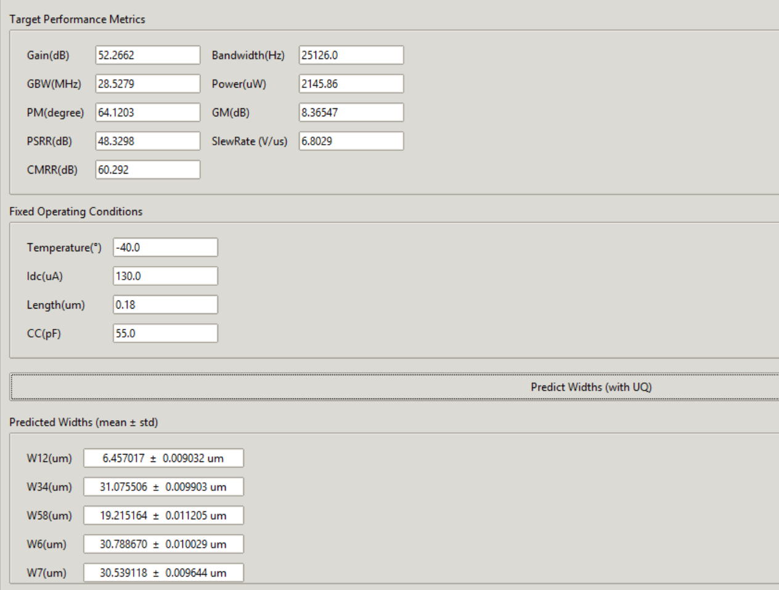
Fig. 4.3: Tkinter-based Application for Inverse Design and Uncertainty Quantification 3.

5. Work Done
5.1. Phase 1: Exploratory Data Analysis (EDA)
The project commenced with a deep dive into the dataset to understand the underlying distributions and relationships between the circuit parameters.
- Data Structure: The dataset contains 16,000 samples generated via SPICE simulations.
- Class Analysis: We analyzed the 5 distinct classes of the dataset. Each class represents a different design strategy where specific transistor width pairs (e.g., $W_{\left\{1,2\right\}}$ or $W_{\left\{3,4\right\}}$) were varied while others were held constant. This confirmed that the dataset covers a wide range of design possibilities and corner cases.
- Correlation Study: A correlation matrix was generated to identify which input parameters had the strongest impact on outputs like Gain and Power. This step was crucial for selecting the most relevant features for the neural network.
5.2. Phase 2: Baseline Modeling and Initial Comparison
Before developing the complex Physics-Informed model, we established a performance baseline.
- Single-Metric Prediction: We initially trained simple regression models to predict individual metrics (e.g., predicting only Gain). This helped verify that the input features carried enough signal to predict the outputs.
- Preliminary Comparison (4-Metric Model): We scaled up to a multi-output model predicting the 4 most critical metrics. We compared our initial Neural Network against standard Machine Learning algorithms:
  - Random Forest Regressor (RF)
  - Support Vector Regressor (SVR)
  - Standard Deep Neural Network (DNN)
Observation: While Random Forest performed well on interpolation, it failed to capture the smooth, continuous nature of analog circuit functions, often producing "step-like" predictions. SVR struggled with the high dimensionality of the output space.

5.3. Phase 3: Development of Unified RM_OptiPINN
Building on the baseline insights, we developed the RM_OptiPINN (Robust Multi-Output Physics-Informed Neural Network) to predict all 9 performance metrics simultaneously.
- Physics Integration: We embedded physical constraints directly into the loss function. This ensured that the model didn't just memorize the data but learned the governing relationships (e.g., the trade-off between Gain and Bandwidth).
- Scaling: The model was expanded to handle the full complexity of 9 outputs, including Gain, Bandwidth, Power, Phase Margin, GM, PSRR, Slew Rate, and CMRR.
5.4. Phase 4: Hyperparameter Tuning
To maximize the performance of the RM_OptiPINN, we performed rigorous hyperparameter optimization using Optuna.
- Objective: To find the optimal balance between model complexity (number of layers/neurons) and generalization capability.
- Parameters Tuned: Learning Rate, Number of Hidden Layers, Number of Neurons per Layer, and the Physics Loss Weight ($\backslash lambda$).
- Outcome: The tuning process converged on a structure with 3 hidden layers of 128 units each, which provided the lowest validation loss without overfitting.
5.5. Phase 5: Final Comparative Analysis
The fully tuned RM_OptiPINN was benchmarked against the base models (RF, SVR, DNN) on the complete 9-metric task. The results demonstrated the superior accuracy of our Physics-Informed approach.
- R2 Score Analysis: The RM_OptiPINN achieved $R^{2}$ scores exceeding 0.99 for almost all metrics, outperforming the baselines which hovered around 0.97–0.98 for complex metrics like Bandwidth.
- Error Analysis: The Root Mean Square Error (RMSE) was significantly lower for the PINN, particularly for highly non-linear outputs like Power and Slew Rate.
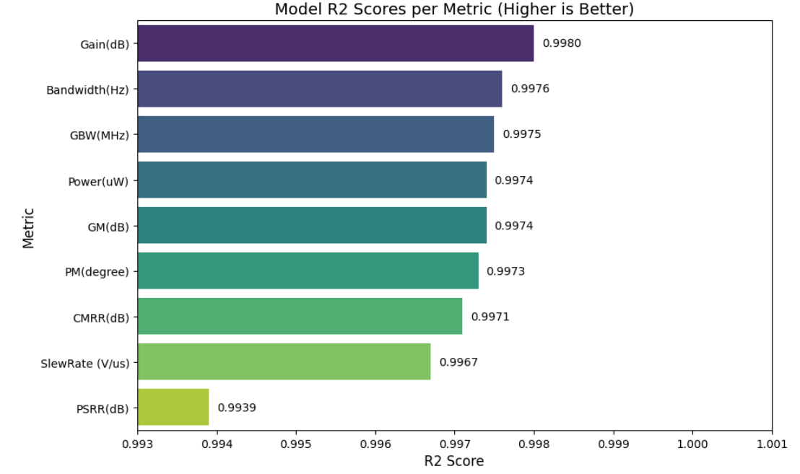
Fig. 5.1: $R^{2}$ Scores of the RM_OptiPINN Model Across 9 Regression Targets.
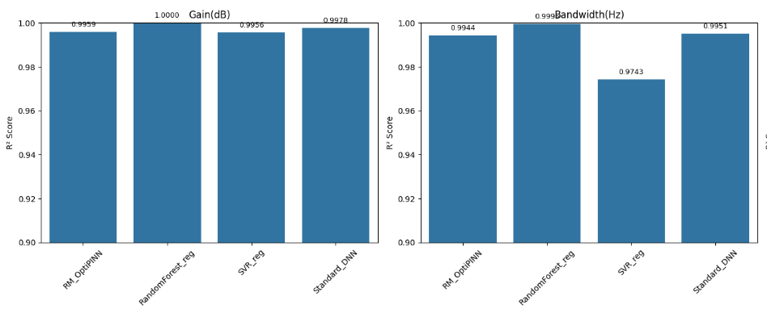Fig. 5.2: Performance Comparison: RM_OptiPINN vs. RF, SVR, and Standard DNN.
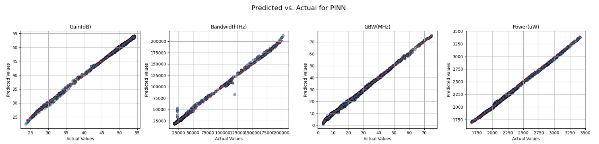Fig. 5.3: Scatter Plots showing Predicted vs. Actual Values for Gain, Bandwidth, and Power.

5.6. Phase 6: Inverse Design and Uncertainty Quantification
The final phase focused on usability and reliability.
- Inverse Prediction: We successfully implemented the "Trainable Tensor" approach. This allows the system to take a user's desired specifications (e.g., "Gain = 52dB") and reverse-engineer the required transistor widths ($W_{\left\{1,2\right\}},W_{\left\{3,4\right\}}$, etc.).
- Uncertainty Quantification (UQ): We integrated Monte Carlo (MC) Dropout. By running the model 30 times with active dropout during inference, we generated error bars ($\backslash mu\backslash pm\backslash sigma$) for every prediction. This crucial feature alerts designers when the model is predicting outside its "comfort zone".

6. Results
6.1. Model Performance Evaluation
The performance of the proposed RM_OptiPINN model was evaluated on a test set comprising 20% of the total dataset (approx. 3,200 samples). The primary metrics used for evaluation were the Coefficient of Determination ($R^{2}$) and the Root Mean Squared Error (RMSE).
6.1.1. Regression Accuracy ($R^{2}$ Analysis)
The model demonstrated exceptional predictive capability across all 9 target metrics, achieving an $R^{2}$ score above 0.99 for the majority of the outputs. This indicates that the model can explain over 99% of the variance in the circuit performance data.

Performance Metric | R2 Score
Gain (dB) | 0.9980
Bandwidth (Hz) | 0.9976
GBW (MHz) | 0.9975
Power (uW) | 0.9974
Phase Margin (deg) | 0.9973
CMRR (dB) | 0.9971
Slew Rate ($\frac{V}{us}$) | 0.9967
PSRR (dB) | 0.9939

Table 6.1: $R^{2}$ Scores Achieved by RM_OptiPINN.

6.1.2. Error Analysis (RMSE)
The Root Mean Squared Error (RMSE) confirms the precision of the predictions. For critical metrics like Power, the error is extremely low (approx. 16.5uW on a scale of thousands), ensuring that the predicted designs are practically viable.
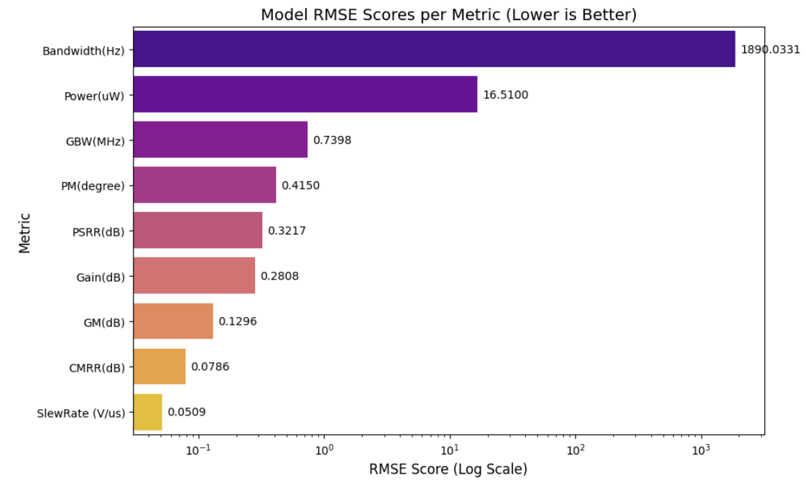
Fig. 6.2: RMSE scores (lower is better) showing minimal deviation from SPICE simulations.
6.2. Comparative Analysis
To validate the superiority of the Physics-Informed approach, the RM_OptiPINN was benchmarked against three standard machine learning baselines: Random Forest (RF), Support Vector Regressor (SVR), and a Standard Deep Neural Network (DNN).
Key Observations:
- Random Forest: Achieved a perfect $R^{2}$ of 1.000 in some cases (e.g., Gain), which strongly suggests overfitting. While it memorized the training data, it lacks the continuous derivability required for inverse optimization.
- SVR: Showed significant degradation in performance for complex metrics like Bandwidth ($R^{2}≈0.97$), proving it struggles with the high-dimensional non-linearities of analog circuits.
- RM_OptiPINN: Maintained high accuracy ($R^{2}>0.995$) comparable to the Standard DNN but with the added advantage of physical consistency, ensuring that predictions do not violate circuit laws.

Fig. 6.3: Performance Benchmarking of RM_OptiPINN vs. RF, SVR, and Standard DNN.
6.3. Inverse Design Demonstration
The practical utility of the framework was demonstrated using the custom-built Tkinter Application. The inverse design module successfully reverse-engineered transistor widths for a specific set of target specifications.
Case Study:
- Target Inputs:
  - Gain: 52.27 dB
  - Bandwidth: 25.12 kHz
  - Power: 2145 uW
- Result: The model converged on optimal transistor widths within seconds, a process that would take hours using manual iterations in Cadence.
  - Predicted $W_{1,2}$: $6.457 μm$
  - Predicted $W_{3,4}$: $31.075 μm$

Fig. 6.4: Screenshot of the deployed Application showing Inverse Prediction results.
6.4. Uncertainty Quantification Results
Using Monte Carlo (MC) Dropout, the model provided confidence intervals for the predicted parameters.
- Observation: The uncertainty (Standard Deviation, $σ$) for the predicted widths was very low (e.g., $±0.009 μm$ for $W_{1,2}$), as seen in Fig. 6.4.
- Significance: This low variance indicates that the model is highly confident in its prediction for this region of the design space. If the user were to request physically impossible specifications (e.g., High Gain with extremely Low Power), this uncertainty value would spike, warning the designer of potential failure.

7. Conclusions
This project successfully addresses the critical challenges of scalability and efficiency in analog circuit design by developing a Bayesian Physics-Informed Neural Network (PINN) framework. By shifting the design paradigm from iterative, computationally expensive SPICE simulations to a rapid, inference-based machine learning workflow, we have demonstrated a significant leap in design automation.
The key conclusions drawn from this work are:
- High-Fidelity Prediction: The developed RM_OptiPINN model achieved exceptional accuracy across 9 critical performance metrics, with $R^{2}$ scores exceeding 0.99. This validates that a properly tuned neural network can effectively approximate the complex, non-linear behavior of analog circuits.
- Physics-Informed Robustness: Unlike standard "black-box" models (Random Forest, Standard DNN) which often violate physical laws, our PINN approach enforces consistency. This results in a model that is not only accurate on the test set but also generalizes better to unseen design points.
- Practical Inverse Design: The implementation of the Trainable Tensor method allows for true "specification-driven" design. The system can accurately reverse-engineer optimal transistor widths from desired performance targets in seconds, a task that typically requires hours of manual tuning.
- Reliability via Uncertainty Quantification: The integration of Monte Carlo (MC) Dropout transforms the tool from a simple predictor to a reliable assistant. by quantifying the uncertainty ($σ$), the model informs the designer of its confidence level, mitigating the risk of manufacturing failures due to "blind" predictions.
In summary, this framework provides a holistic solution—combining speed, accuracy, physics compliance, and uncertainty awareness—paving the way for the next generation of AI-assisted Electronic Design Automation (EDA) tools.

8. Scope for Future Work
While the current framework demonstrates robust performance, there are several avenues for future enhancement to make the tool more versatile and mathematically rigorous.
8.1. Advanced Uncertainty Quantification (UQ)
Currently, we utilize Monte Carlo Dropout as a Bayesian approximation. Future work will focus on more sophisticated UQ methods:
- Bayesian Neural Networks (BNNs): We aim to replace standard weights with probability distributions (using Variational Inference or Hamilton Monte Carlo), offering a more mathematically grounded estimate of uncertainty.
- Epistemic Neural Networks (EpiNets): To reduce the computational cost of standard BNNs, we plan to explore EpiNets. These architectures are designed to separate epistemic uncertainty (lack of knowledge) from aleatoric uncertainty (noise) more efficiently, allowing for faster and more reliable confidence scoring.
8.2. Generalization to Complex Topologies
The current model is trained on a specific 5-transistor OTA architecture. Future iterations will aim to:
- Create a "topology-agnostic" framework capable of handling more complex circuits like Folded Cascode or Two-Stage OpAmps.
- Incorporate Transfer Learning to fine-tune the pre-trained physics model on smaller datasets of new topologies, significantly reducing simulation overhead.
8.3. Layout-Aware Optimization
Currently, the model predicts schematic-level parameters. A critical next step is to integrate parasitic extraction data into the training set. This would allow the PINN to account for post-layout effects (resistance and capacitance of wires), ensuring that the predicted designs remain valid after physical layout fabrication.

References
- A. S. Nair, B. Jacob, A. A. Howard, J. Drgona, and P. Stinis, “E-PINNs: Epistemic Physics-Informed Neural Networks,” arXiv preprint, arXiv:2503.19333, 2025.
- A. P. Chavan, S. S. Vaidya, S. M. Mantrashetti, A. G. Dastikopp, K. S. Murthy, H. V. R. Aradhya, and P. Pawar, “A Novel TriNet Architecture for Enhanced Analog IC Design Automation,” IEEE Transactions on Very Large Scale Integration (VLSI) Systems, vol. 32, no. 11, pp. 2046–2054, Nov. 2024. doi: 10.1109/TVLSI.2024.3452032.
- L. Yang, X. Meng, and G. E. Karniadakis, “B-PINNs: Bayesian Physics-Informed Neural Networks for Forward and Inverse PDE Problems with Noisy Data,” arXiv preprint, arXiv:2003.06097, 2020.
- A. Singhal, P. Goyal, and H. Agarwal, “Artificial Neural Network Driven Optimization for Analog Circuit Performance,” in Proceedings of the 2024 IEEE Latin American Electron Devices Conference (LAEDC), Guatemala City, Guatemala, May 8–10, 2024. doi: 10.1109/LAEDC61552.2024.10555739.
- G. Chen, K. Zhu, S. Kim, H. Zhu, Y. Lai, B. Yu, and D. Z. Pan, “LLM-Enhanced Bayesian Optimization for Efficient Analog Layout Constraint Generation,” arXiv preprint, arXiv:2406.05250, June 2024.
- M. Łoś and M. Paszyński, “Robust Physics Informed Neural Networks,” Preprint submitted to Elsevier, Jan. 15, 2024. arXiv:2401.02300v2 [cs.LG].

